Title:

Report of Human AI-Collaboration in Generating Calming Art for Hospitals (Using Both Pretrained and Scratch Trained Models)

By: Natalie Fong

Abstract

In hospital areas dedicated to chronic disease or recovery, the atmosphere can often be disquieting. Patient studies indicate a preference for specific artworks that can effectively enhance calmness and mood. This project aims to expand the selection of such artworks by utilizing both scratch-trained and pre-trained models, guided by human input. The methodology involves identifying key characteristics of artwork known to evoke calesss, including subjects and color palettes. Image synthesizers are then employed to generate images, which are filtered to meet the predefined criteria of calmness based on research findings. Finally, various generative adversarial network techniques are employed to augment and diversify the collection of artworks.

When thinking about the hospital, whether it is for a short stay or being bedriven there from chronic diseases, a lot of people think of a very disquieting and uncomfortable place. Monotonous with the repetition of a bed and medical equipment and white walls covering the room, it is difficult for a more comfortable atmosphere to be created. However, it could be seen in Figure 2 that just by adding a painting and some colors, the atmosphere of the room has seemingly ameliorated.

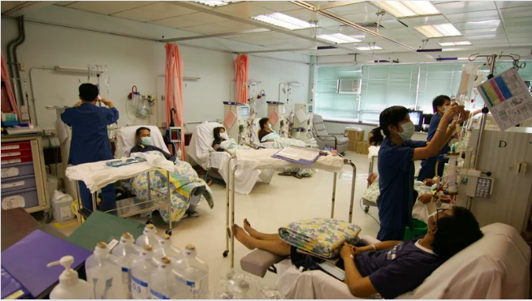

Figure 1

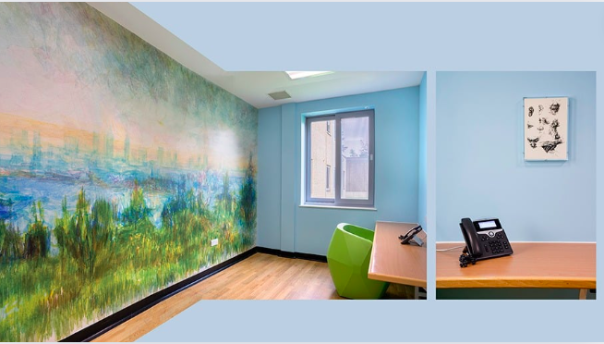

Figure 2

This matter has been further investigated. According to Dr. Staricoff’s study done upon 91 patients between the ages of 20-90[1], 80% reported that art improves mood; 47% found art effective in distracting themselves from medical worries; 65% claimed that it eases stress levels. 87% have also claimed that visual arts is the key and main element for rendering a “pleasant environment. Currently a lot of artworks are produced by renowned painters including, Mary Fedden, Julian Trevelyan, Lisa Milroy, Keith Grant and more according to organizations such as imperial health charity[2]. Being able to obtain artworks from renowned artists for the hospital is a very positive thing, as professionals in charge are able to choose from a pool of ready artworks and request to have them displayed in the hospital with the consent of the artist. However, according to another source, some artists are reluctant to commission artworks for the hospital. This is due to the fact that they are “concerned for the safety of their artworks”[3] and some reported that no “maintenance has not been performed on their artworks as promised”. Therefore, there is a limited pool of artworks coming from renowned artists.

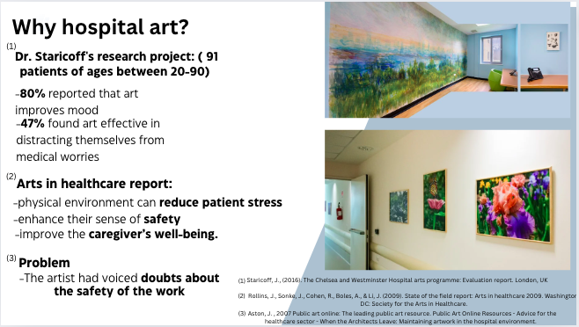

Figure 3

Another source for hospital art could also be donated from the general public or people could even volunteer to paint paintings or murals for hospitals. These are all amazing ways for generating art for the hospital. However, another study conducted by national library of medicine[4] out of a pool of 3707 art pieces from the art catalog of the Danish art museum, 20 art pieces were narrowed down, and have been presented to 103 patients of different age groups for only 5 to be selected as their favorite art pieces. The patients have selected 1,2,3,5, 20 as their preferred paintings, where ⅘ of the paintings are a landscape. This reflects how although any one can volunteer to create art for the hospitals, artsworks may not always have the same calming effect on the patients and be preferred by them.

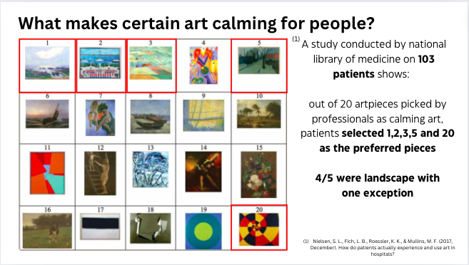

Figure 4

This leads to my design problem. I would like to create a project where I aim to expand the selection of such artworks through using Ai, both scratched trained and pretrained models to explore different ways for art generation, yet guided by my human input. The artwork generated has the goal of both acting as a blueprint of inspiration for volunteers to follow to create artworks that are objectively more calming throughout different genders and age groups. Secondly, the generated art could potentially be printed out and be used in hospitals even if there are a lack of volunteers to paint artworks, which although less effective without the worthy of admiration element of paintings, could potentially still help to enlighten the hospital mood.

To implement this goal, 3 methods would be used. This first method would be the most basic of converting text to images through an Ai text to image generator. This method would have a larger focus on my research of gaining the correct keywords as a prompt to generate image that are calming, setting a good foundation for my project. However, Ai generator is less precise in a sense where many images which are very diverse would be generated upon using one keyword. This is a great way to brainstorm a lot of clear images very quickly, however, it would be hard to control the output into exactly what is wanted based on research. Thus, the second and third method which is a scratch-trained model is used, in order to explore more various ways to have more control over the output. Additionally, 3 types of Ai tools would be used, this includes Ai image generator which is a text-to-image ai generator. Next, an Ai vision would be used, generating a description from an image. Lastly, neural network would be used which would be GAN.

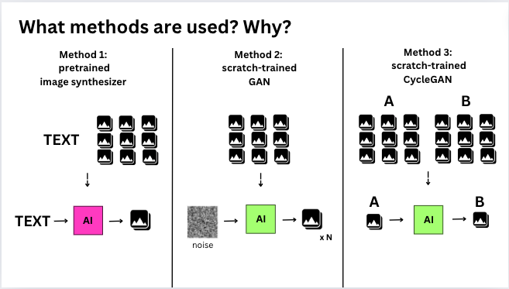

Figure 5

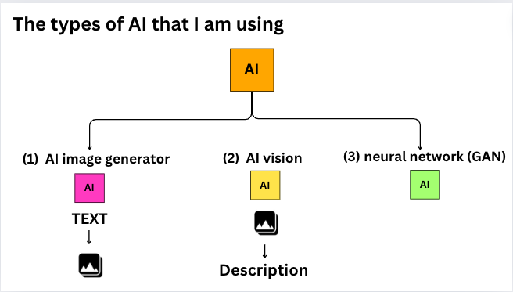

Figure 6

As for the pipeline of my project shown in Figure 7. The project would begin through researching characteristics of subject matters that calming through reading academic journals. The research would then be organized into a table where keywords would be exerted for prompt for the text-to-image generator. Around 50 images would be generated from the research which would be narrowed down to a few images best fitting my research after running through some assessments. Based on the qualities of these narrowed down few images, more images, over 500, would be generated through the text-to-image generator. These 500 images would then be used as the input dataset for GAN. Yet throughout the progress, some assessments would be ran in between to enhance the reliability of some of the outcome which would originally be more subjective.

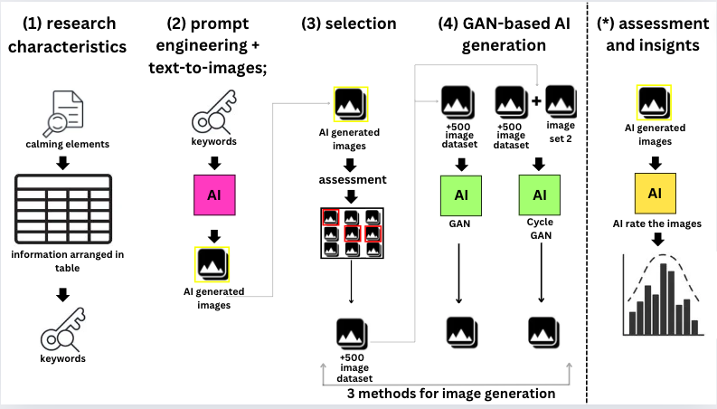

Figure 7

In regards to the research of aspects that allows artworks to be calming. According to thea study conducted by Roger S. Ulrich[5], the study group expressed their liking for both landscape and nature sceneries. This is “consistent with certain evolutionary psychological theories, which predict positive emotional responses to flourishing natural environments.” Additionally, according to another academic study[6] conducted by several researches **on** 27 university students, a more objective conclusion was deduced. The outcome reflected how plants including bonsai trees, foliage plants, or flowers in general are effective in having relaxing effects on the brain through observing autonomic nervous systems. Another study[7] from the National library of medicine conducted upon 19 female university students also shows that visuals of roses were affected in “ a significant decrease in oxy-Hb concentrations in the right prefrontal cortex” which is associated with increase of perceptions regarding feeling comfortable and relaxed, as well as an improved mood state.” Regarding the reasoning behind why landscapes are generally more preferred over portraits, this is because according to an article, human emotions presented through an artwork may potentially be absorbed by the viewer, increasing the probability of negative or feelings of ambivalence to be induced. Other than that, one more study[8] conducted upon 43 women and 40 men ranging from 20 to 90 years of age suggested that greens and blues increased relaxation and calm feelings of participants compared to the other colors. Similarly, expectant mothers in specific also prefer aquatic or earthly colors. Upon conducting these research, the key information would be highlighted as well as the keywords, then organized in a table as seen in the image below.

The table can be seen in the image below in Figure 8, where it is divided into sections of keywords, who the research is conducted on, information of the source (backing up the keyword), and also the source of where the information is from. From these information keywords are drive to be used as prompt for the text to image generator generating around 50 images.

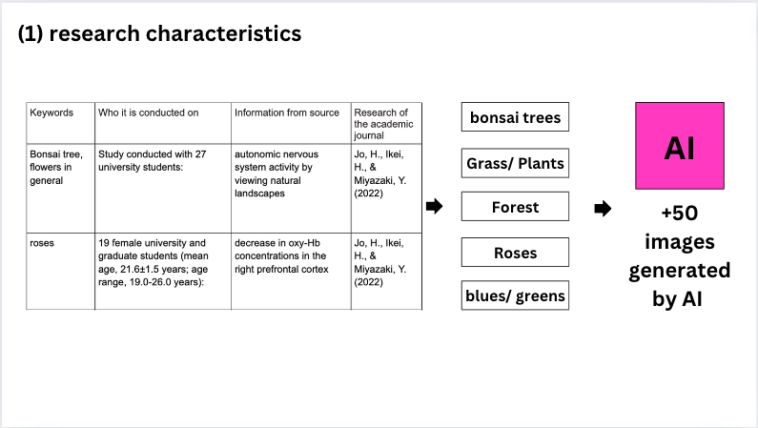

Figure 8

For more information on how assessments are done. The 50 images generated from Ai image generator would then be scored by an AI vision upon asking AI some questions. Images with a higher score for these questions would be filtered out. The qualities of these filtered out images would then be exerted with the help of Ai for even more keywords to be generated, which would be used to generate 500 plus images as input of GAN.

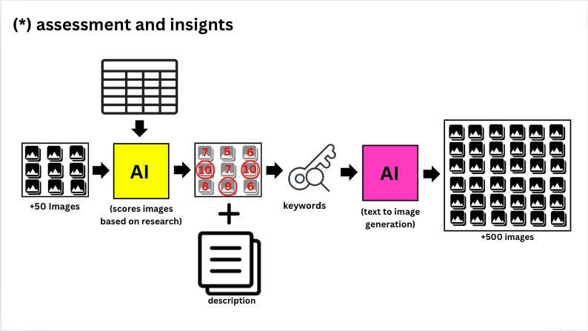

Figure 9

For more details, as seen in figure 10, 2 questions were asked including A: “rate this image based on how much it matches the description of my research on a rate of 1-10” and B:“ rate this image for it’s calmness and ability to improve mood on 1-10”, where two scores would be generated for both A and B. These images with a high score for both would be selected to proceeded.

For question B, due to the fact that asking Ai to rate an image out of its “calmness” is very subjective, another assessment of histogram is performed. Using a jupyter notebook, I have created some codes that performs an analysis on the color pixels of each image that has a high score for calmness, which would be score 9 and 10. I have overlapped the histograms of each colors of red, green and blue, which could been seen in Figure 11. In the histograms, the x axis is the color intensity of each color, while the y axis is the number of color pixels of that color. The results reveal that for the color of blue and green although there are more color pixels on the lighter side, there are also plenty of color pixels of more intense colors (darker and more saturated blues and greens). It is not limited to only lighter blues and greens. For the color pixels of red contrarily, it only reveals a higher number of pixels on the lighter intensity of the color red, meaning color that are pastel orange or pink, however, there is an outlier as seen which could possibly be the colors of certain plants. Therefore, a common pattern could be deduced which also matches my research.

As for question A, as seen in Figure 12, when asking Ai to rate the image based on it’s calmness I would paste the keywords derived from my previous research (which is organized in a table) as a benchmark for the Ai to score the images. The more it matches the description of the keywords, the higher the score, would be. As seen in Answer from AI section”, not only a score but a reasoning for why AI has produced that score would also be generated. I would then paste the description into AI and ask it to “narrow it down to only 10 keywords” leading to “Description <keywords” section. The keywords that appears the most, as in with the highest repetition would be selected. Currently, along with the keywords generated in the first round (for my first batch of 50 images) along with more keywords.

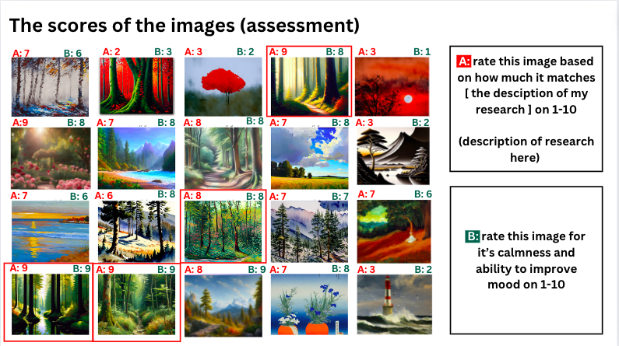

Figure 10

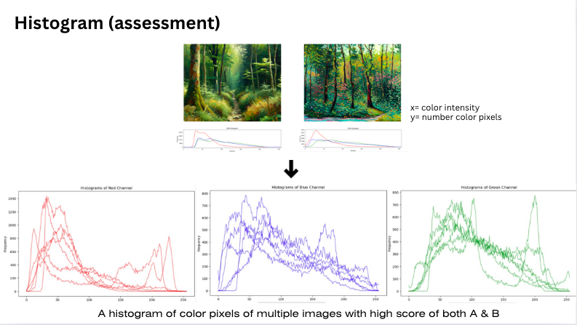

Figure 11

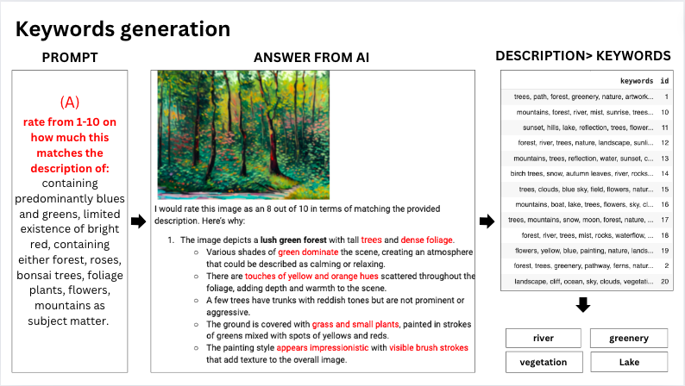

Figure 12

Figure 13 shows a sample of some of the 500 images generated from Ai image generator from the keywords of Figure 12.

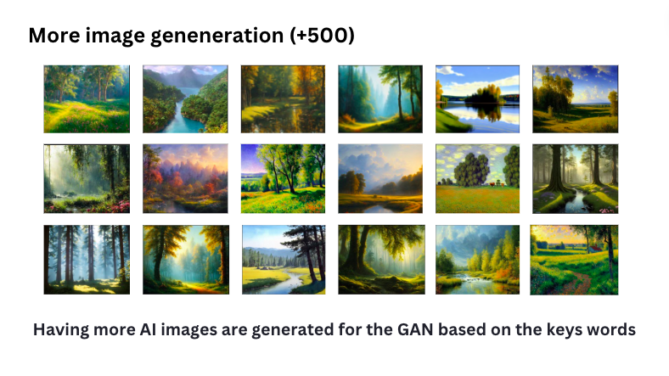

Figure 13

Proceed to explain how these data would be used as the input data of GAN, in simple words, Gan involves in a generator which learns to turn noise into something that captures the quality of your input image dataset which is the calming images that I have handpicked. So, basically it generates a bunch of new images has the qualities of the original dataset (my calming images), and oftentimes GAN ends up blending the elements of the original image as outcome. (see Figure 14)

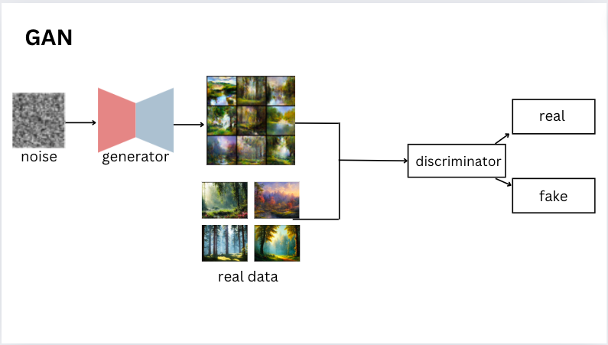

Figure 14

Figure 15 reveals the results from GAN. Bylooking at these results certain patterns have emerged. We can see that it appears that GAN tends to organize these images into distinct clusters based on their similarities. As seen in figure 16, I have roughly shown a few examples of groupings of similarities that I have noticed.

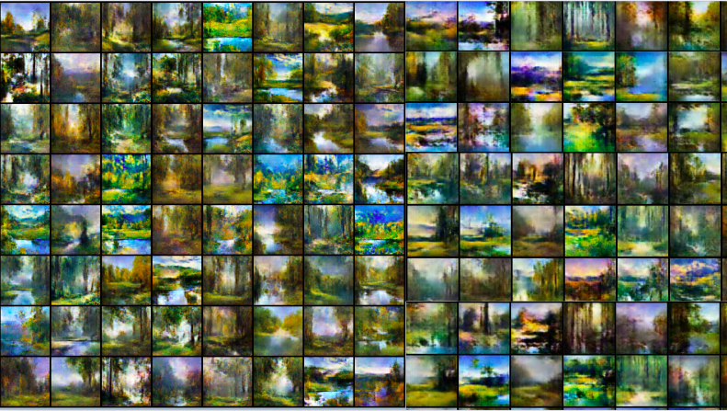

Figure 15

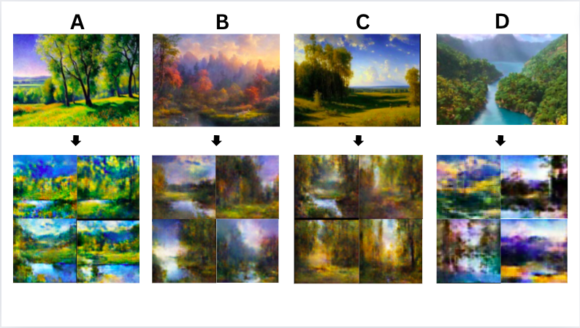

Figure 16

Therefore, the images don’t look surprising different. GAN doesn't mix elements from different groups for instance group a and b in figure 16 to produce images that look very innovative.

The second limitation is that the images are still very blurry. This is because it is done by one computer and my own computer with a short training period so there is a limited resolution. This is still a preliminary technique that is still work in progress, so the implementation has not been optimized

Additionally, another limitation would be that we have very little control over what we want the output images to look like, it just tends to blend the qualities of the original photoset randomly. We are unable to control the subject matter of the images. Therefore, this leads to a necessity to explore the third method, cycle GAN.

Cycle GAN functions similarly to GAN. However, instead there would be two sets of images, which are real image A and real image B as seen in Figure 17. Real image A would be the images that you input which would receive the changes, in my case it would be some depressing images on the top right, then in real image B it is the qualities that I want my real image A, the depress images to learn from. The generator would then generate images that has the basic components of real image A as seen here. In others words the generator would learn to convert depress images to a style closer to calming images.

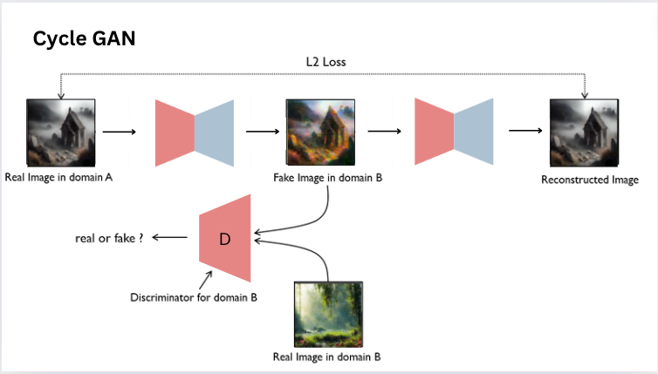

Figure 17

Figure 18 shows the results of cycle GAN where as seen, A is the input, and would be coveted to the output of B having gone through the generator. The images pointing towards the generator are the calming images, indicating how these are also the input for generator for output B to gain it’s style upon going through the generator. As seen in the results, A in my personal opinion has the best transformation, where not only the colors has been transformed with more proximity of the color palettes of the calming images, but grass and trees in the background has also been added, matching the subject matter of the calming images more.

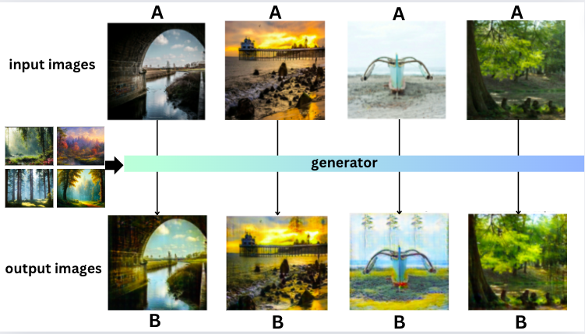

Figure 18

Additionally, I have tried observing the results of input images of nature landscape to see how Cycle Gan would transform these images, which are images that carries the subject matter of my “calming images” dataset. From what I notice from the results of figure 19, the further away the color palette of the image A is from the calming images, the more room there is for transformation from cycle GAN. This example can be seen in the images at the bottom right of figure 19 where more greens and blues as well as yellow green are installed, resembling my calming images more instead of the dull blue and brown tree sticks seen in the original A.

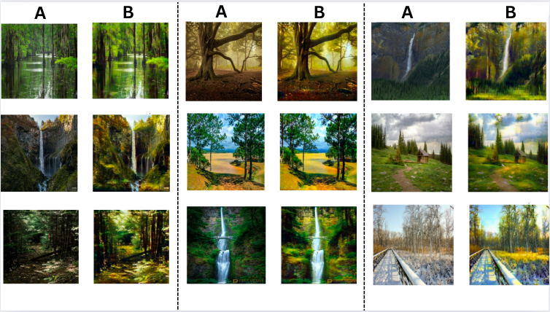

figure 19

I have also tried looking into images that are not related to nature as input for Cycle GAN. As seen in figure 20. Even with black and white images, it tends to reinstall the colors of the blue sky and attempts to add nature like colors such green or orange to the subject matter, which are once again color palettes derived from the calming images.

However, a clear limitation could be seen which is more apparently shown in figure 20, an image with a subject matter that is not calming to begin with such as a human face, or a blurry graveyard would not be converted to something calming through Cycle Gan as all it does is act as a filter for the image. The overall attributes of the original image remain where the subject matter wouldn't be converted. Therefore, for the case of my hospital art, to optimally make use of cycle gan, images of landscape should already be prepared, allowing Cycle Gan to further adjust it to look more “calming” based on my research.

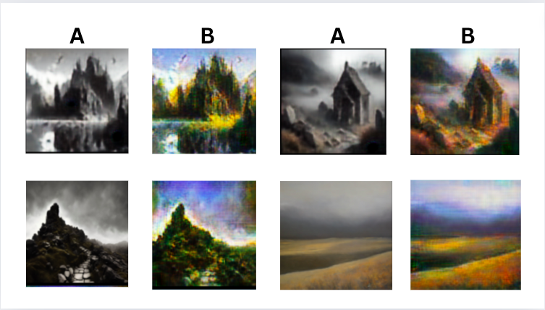

Figure 19

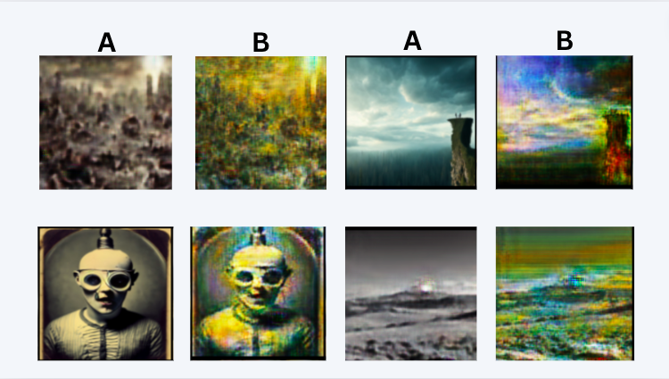

Figure 20

Another curious insight that has been briefly touched upon is that I have also trained a model that learns to transform images in the reversed direction which means calming to depressing images as seen in figure 21. As seen, in this case, the results of gloomy images almost always works in that case as it just blurs the subject and gives it gloomy colors.

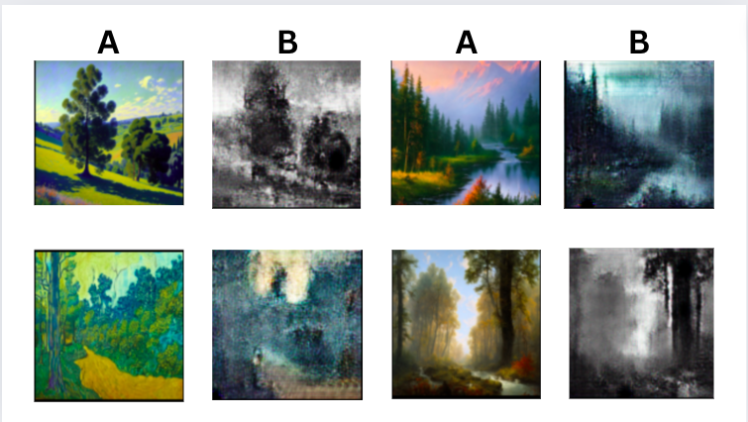

Figure 21

Regarding the general limitation of this project, there are a few key points. Firstly, there are more sophisticated methods like stable diffusion, which are text to image generators so the quality of the image could be better than GAN. However, the advantages of using GAN is that there is a more tailored way to specially generate images the way you want it.

Another limitation would be that, although I have used research to backup on definition elements that are objectively of calming for different ages and gender, the concept of calming remains subjective and the results of the artwork outcomes may not please everyone.

The last limitation would be my own skills and timeframe I acknowledge that more image generation methods could be explored.

This would lead to the future outlook of the project, in the future, if I were to develop my skills, perhaps I could use insights of the histogram to help the model to train better, having the output images of Gan following the color scheme that is the guided by the insights of the histograms.

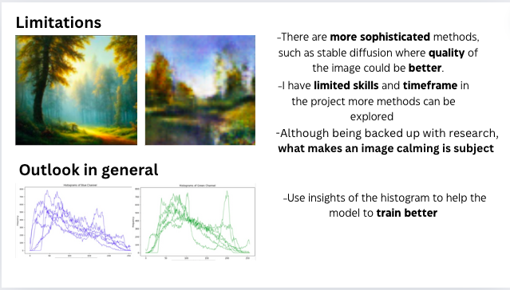

Figure 22

In summary, I have basically explored used 1 method of pretrained model and 2 methods of scratch trained model where we can see the difference of degrees of control of our output. From minimal control with text to image generator, to having a lot of control with m the cycle GAN since it acts more like an image filter. Yet all of them have their own advantages and disadvantages. Ultimately, if the paintings inspired by the output images of Gan or the output images were to be printed and placed directly in a hospital, ideally this would be how it looks like. This could potentially enlighten the monotonous environment of a hospital just by adding some variation of colors and subjects that are calming to look at based on research. This would be useful especially for rooms without a big window visible. Additionally, it allows the overall environment to be less“prison” like an environment.

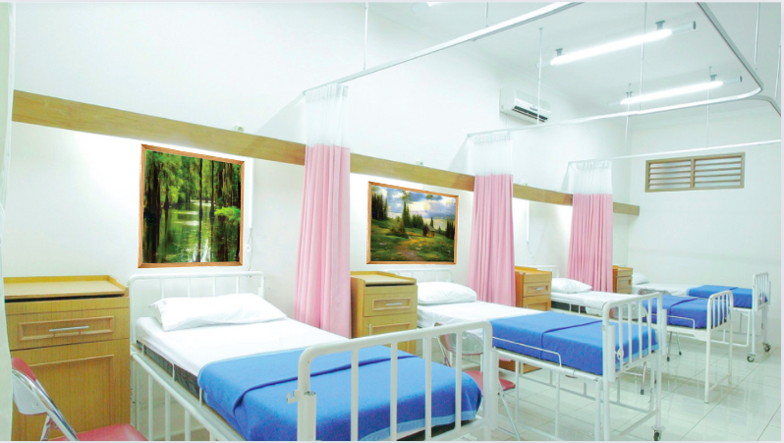

References:

*Microsoft Research Limited Fund*. Cambridgeshire Community Foundation. (2024, May 15). https://www.cambscf.org.uk/microsoft-research-limited-fund

Made Simple Media | www.madesimplemedia.co.uk | info@madesimplemedia.co.uk. (n.d.-b). *Our art collection*. Imperial Health Charity. https://www.imperialcharity.org.uk/arts/the-collection

*Public art online: The leading public art resource*. Public Art Online Resources - Advice for the healthcare sector - When the Architects Leave: Maintaining artwork in the hospital environment. (n.d.-a). https://publicartonline.org.uk/resources/practicaladvice/advicehealthcare/hospital_artwork_maintenance.php.html

Nielsen, S. L., Fich, L. B., Roessler, K. K., & Mullins, M. F. (2017a, December). *How do patients actually experience and use art in hospitals? the significance of interaction: A user-oriented experimental case study*. International journal of qualitative studies on health and well-being. https://www.ncbi.nlm.nih.gov/pmc/articles/PMC5328392/

Ulrich R.(1993) *The biophilia hypothesis.* Washington, DC: Island Press; https://www.researchgate.net/publication/284655696_Biophilia_biophobia_and_natural_landscapes

Jo, H., Ikei, H., & Miyazaki, Y. (2022). Physiological and Psychological Benefits of Viewing an Autumn Foliage Mountain Landscape Image among Young Women. *Forests*, *13*(9), 1492. <https://doi.org/10.3390/f13091492>

Igarashi M;Song C;Ikei H;Ohira T;Miyazaki Y; (n.d.). *Effect of olfactory stimulation by fresh rose flowers on autonomic nervous activity*. Journal of alternative and complementary medicine (New York, N.Y.). https://pubmed.ncbi.nlm.nih.gov/25055057/

A study of the effects of visual and Performing Arts in health ... (n.d.-a). https://publicartonline.org.uk/resources/research/documents/ChelseaAndWestminsterResearchproject.pdf

1. *Microsoft Research Limited Fund*. Cambridgeshire Community Foundation. (2024, May 15). https://www.cambscf.org.uk/microsoft-research-limited-fund
2. Made Simple Media | www.madesimplemedia.co.uk | info@madesimplemedia.co.uk. (n.d.-b). *Our art collection*. Imperial Health Charity. https://www.imperialcharity.org.uk/arts/the-collection
3. *Public art online: The leading public art resource*. Public Art Online Resources - Advice for the healthcare sector - When the Architects Leave: Maintaining artwork in the hospital environment. (n.d.-a). https://publicartonline.org.uk/resources/practicaladvice/advicehealthcare/hospital_artwork_maintenance.php.html
4. Nielsen, S. L., Fich, L. B., Roessler, K. K., & Mullins, M. F. (2017a, December). *How do patients actually experience and use art in hospitals? the significance of interaction: A user-oriented experimental case study*. International journal of qualitative studies on health and well-being. https://www.ncbi.nlm.nih.gov/pmc/articles/PMC5328392/
5. Ulrich R.(1993) *The biophilia hypothesis.* Washington, DC: Island Press; https://www.researchgate.net/publication/284655696_Biophilia_biophobia_and_natural_landscapes
6. Jo, H., Ikei, H., & Miyazaki, Y. (2022). Physiological and Psychological Benefits of Viewing an Autumn Foliage Mountain Landscape Image among Young Women. *Forests*, *13*(9), 1492. <https://doi.org/10.3390/f13091492>
7. Igarashi M;Song C;Ikei H;Ohira T;Miyazaki Y; (n.d.). *Effect of olfactory stimulation by fresh rose flowers on autonomic nervous activity*. Journal of alternative and complementary medicine (New York, N.Y.). https://pubmed.ncbi.nlm.nih.gov/25055057/
8. A study of the effects of visual and Performing Arts in health ... (n.d.-a). https://publicartonline.org.uk/resources/research/documents/ChelseaAndWestminsterResearchproject.pdf